**Creating a new object using constructor function Object()**

To create a new object by using constructor function **Object()** we use the next syntax:

**Syntax:**



**Example:**

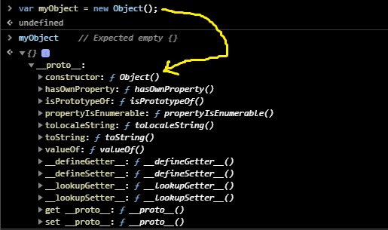

**Note:**

* Any object has **this** reference variable inside it.
* Any object has a __proto__
* __proto__ is a reference variable or accessory property (a getter function and a setter function).
* __proto__ contains a block of properties stored inside a box called “**prototype**”.

**Illustration of the previous example:**

**The execution of the previous example done on the following steps:**

1. JS engine first execute **var** keyword, an empty location memory was created with **Car** name an **undefined** value (default value).
2. Then it move to Assignment operator (=) to store (assign) right side value inside left side variable. because right side value wasn’t known yet; JS engine will execute the right side statements to find its value, and then assign it in the left side.
3. JS engine moves to execute **new** keyword, which is used to:
4. Create an empty memory location object with __proto__ variable inside it. To access to prototype property we use constructor (Object) As a pointer; so we write: **Object.prototype**

